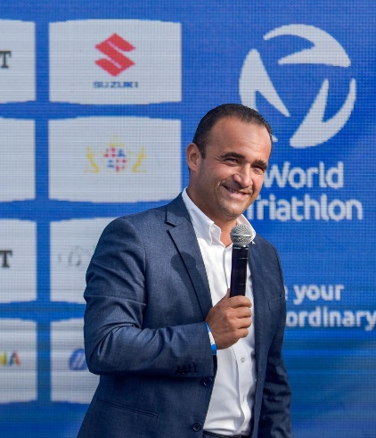
Riccardo Giubilei
Born in Terni, Italy – 22/06/1973
E-mail: riccardogiubilei@fitri.it

Roles in the Italian Triathlon Federation (FITri):
- President of the Italian Triathlon Federation (since March 2021)
- First (Deputy) Vice President of the Italian Triathlon Federation (2018-2021)
- President of the Age Group Commission (2016-2020)
- FITri Board Member (2016-2020)
- Member of the FITri Consulta - Council of Territories (2014-2021)
- FITri Delegate for the Umbria Region (2014-2021)

International Roles:
- Board Member of the Mediterranean Triathlon Federation (since March 2021)

Key Achievements as FITri President:
- During the first mandate as President, the first-ever World Triathlon Championship Series has been organized in Italy in Cagliari in 2022, followed by 2023 and 2024 edition (and counting)
- During the first mandate as President, the World Triathlon Cup was organized in Rome in 2023 for the first time, followed by the edition of 2024.
- During his mandate and under his guidance, Italian Triathlon Federation, as leading organization, was the first sport federation ever securing two European Erasmus projects with the inclusion of 20 European National Federations: Erasmus EUTriWeek (2024-2025) and Tri4All (Paratriathlon, 2025-2026) for a total budget of € 900.000.
- Launch of the project "Il Triathlon Entra a Scuola" to promote triathlon among young students in partnership with primary and secondary schools.
- Promoter and facilitator of the inclusion of Triathlon in the Mediterranean Games program starting from the 2026 edition
- Promoter and facilitator of the official request of inclusion of Winter Triathlon as a demonstration sport at the 2026 Milano-Cortina Winter Olympic Games.

Honors & Awards:
- Commendatore al Merito Sportivo - Decreto of the President of the Italian Republic (27/12/2022)
- CONI Medaglia d’Oro al merito sportivo - Gold Medal for Sporting Merit (2021)
- Comitato Italiano Paralimpico Medaglia d’Oro al merito sportivo - Gold Medal for Sporting Merit (2021)

Management Positions in Sports Associations:
- Vice President of the Comitato Italiano Paralimpico (since June 2025)
- Member of the CONI Budget Commission (since June 2021)
- Member of the CONI National Council (since March 2021)

Education:
- Master’s Degree in Marketing and Business Administration, LUISS Guido Carli University, Rome
- Law Degree, University of Perugia
- Degree in Oboe, Giulio Briccialdi Conservatory, Terni
- High School Diploma in Classical Studies, C. Tacito High School, Terni

